Unit 4 Sample Homework 2

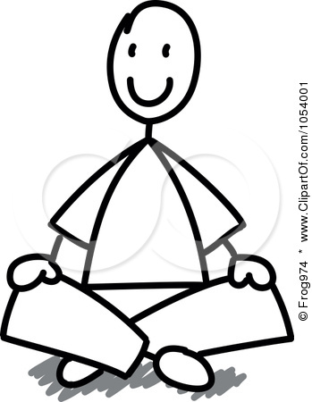
1. A 60 kg student sits 2.0 m from the left end of a 20 kg wooden board is 6.0 m long. The board is balanced on two bricks, the first brick located 1.0 meter from the left end,
2 m

Brick
20 kg wooden Board

1.0 m
2.0 m
3.0 m
and the other brick 2.0 m
from the right end.

a. Draw a FBD of the board.

b. What is the magnitude of the force that each brick provides on the board?

c. The 60 kg student stands up and walks towards the right end of the board. At what point will the board tip (Hint: What will be the force provided by the left hand brick at this point?)

2. A 1.0 kg meterstick is held horizontally by one finger placed at its midpoint.

- Draw a FBD of the meterstick for this situation.

- What is the force that the fingers exert on the meterstick?

3. The 1.0 kg meterstick is held horizontally by two fingers, one placed at 0.05 m and the other placed at 0.95 m.
- Draw a FBD of the meterstick for this situation.

- What is the force that the fingers exert on the meterstick?

4. The 1.0 kg meterstick is held horizontally by two fingers, one placed at 0.95 m and the other placed at 1.0 m.

- How must these two fingers be arranged to balance the meterstick when they are placed in these specific locations?

- Draw a FBD of the meterstick for this situation.

- What is the force that the fingers exert on the meterstick?

2.

0.80 m
1.2 m
Pt. A
Pt. B
60 N

0.80 m
1.20 m
Pt. A
Pt. B
60 N

0.80 m
1.20 m
Pt. A
Pt. B
60 N
6 m
Brick
20 kg wooden Board

1.0 m
2.0 m
3.0 m

20 m
Support Post
Beam

3.0 m
7.0 m
10 m

2 m
Brick
20 kg wooden Board

1.0 m
2.0 m
3.0 m

6 m
Brick
20 kg wooden Board

1.0
2.0 m
3.0 m

